TASK | An anti-seize compound which provides an insulating layer between metals to prevent fusion
LOCATION OF USE | Workshop and field engineers |  | Assessment  No |  | 010
PRODUCT NAME | Copaslip (Molyslip) |  |  |  | 010
DESCRIPTION OF SUBSTANCE | Yellow/gold coloured paste |  |  |  | 010
MANUFACTURER | MolySlip Atlantic Ltd |  |  |  | 010
MANUFACTURERS CONTACT | A1 Danebrook Court  Oxford Office Village, Langford Lane,  Kidlington  Oxfordshire  OX5 1LQ  Tel: 01865 370032  Fax: 01865 372030  Email: enquires@molyslip.co.uk |  |  |  | 010
ASSESSOR | Martin Monaghan CMIOSH |  | Date |  | 23 07 24
TITLE | Health and Safety Consultant |  | Review by |  | 23 07 26
Personnel Performing Task  (Please list below)  Technicians/ Fitters/ Workshop Operatives |  | Time Spent  (Minutes/day)  As and when required, amounting to a few minutes per day | Training Given 
 |  |  | Yes

MSDS Revision Date | Hazard Statement
06/04/2018 Rev:5 | H301 Toxic if swallowed.  H302 Harmful if swallowed.  H311 Toxic in contact with skin.  H319 Causes serious eye irritation.  H331 Toxic if inhaled.  H373 May cause damage to organs through prolonged or repeated exposure.  H400 Very toxic to aquatic life.  H410 Very toxic to aquatic life with long lasting effects.  H411 Toxic to aquatic life with long lasting effects.

Assessment to be conducted in Association with Hazard Data Sheets, a full current copy of which must be attached to this assessment.

Please denote the hazardous properties of the substances used in the task with a

NEW INTERNATIONAL GLOBALLY HARMONISED HAZARD SYMBOLS
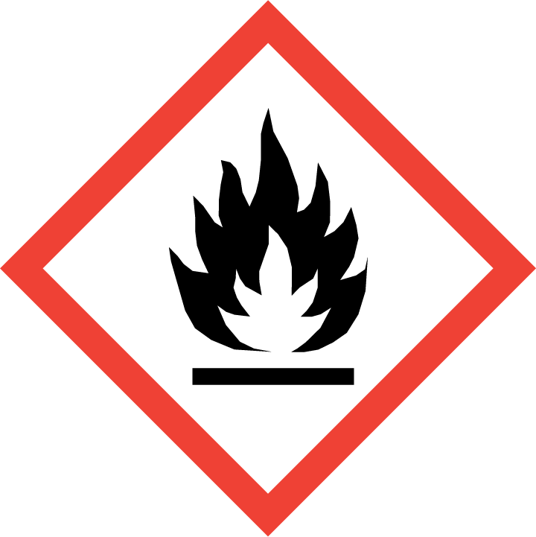 | 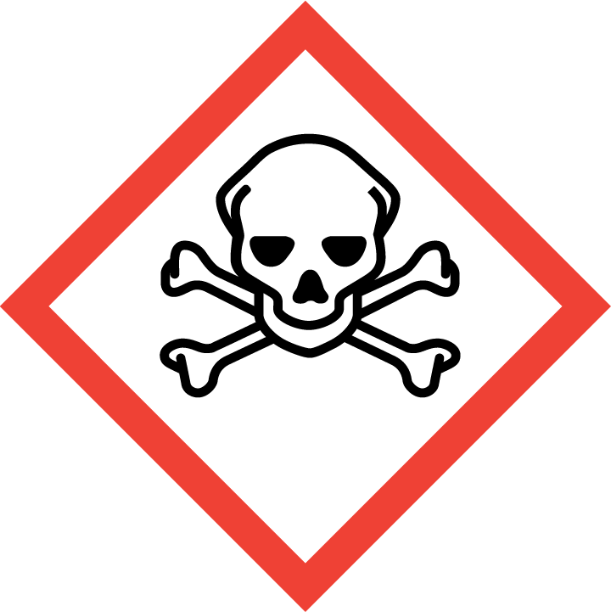 | 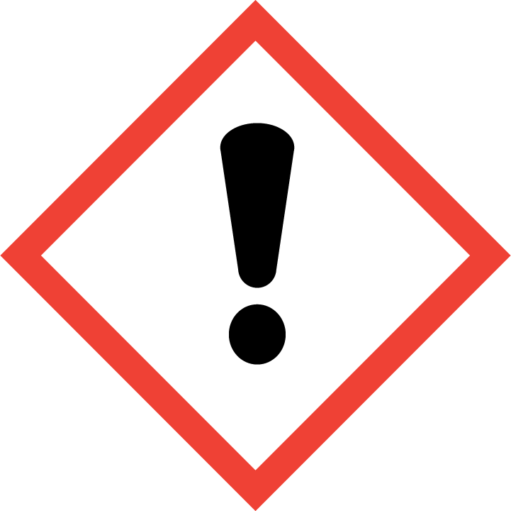 | 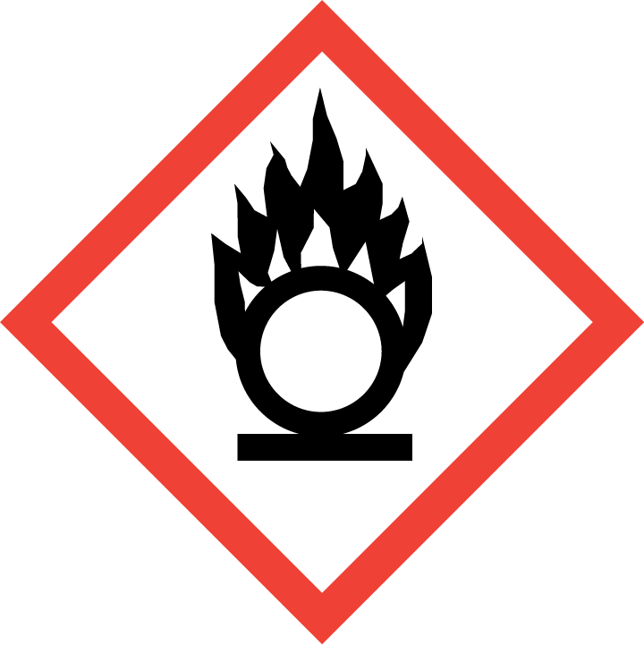 | 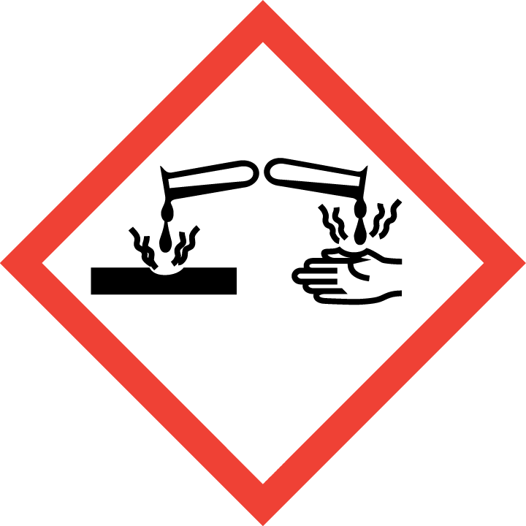 | 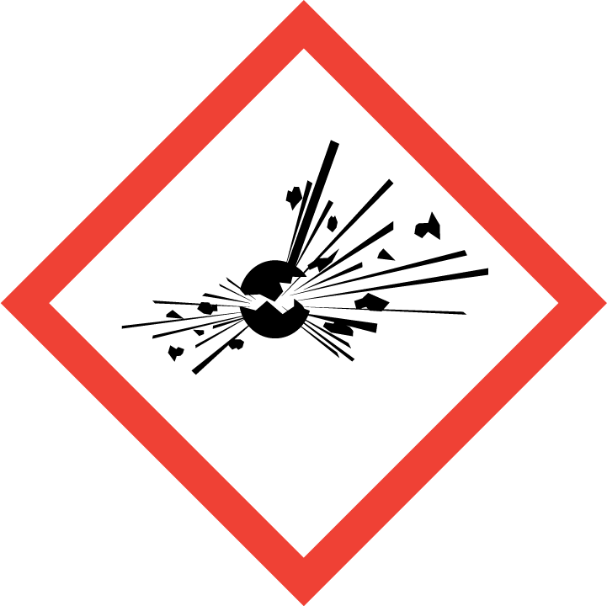 | 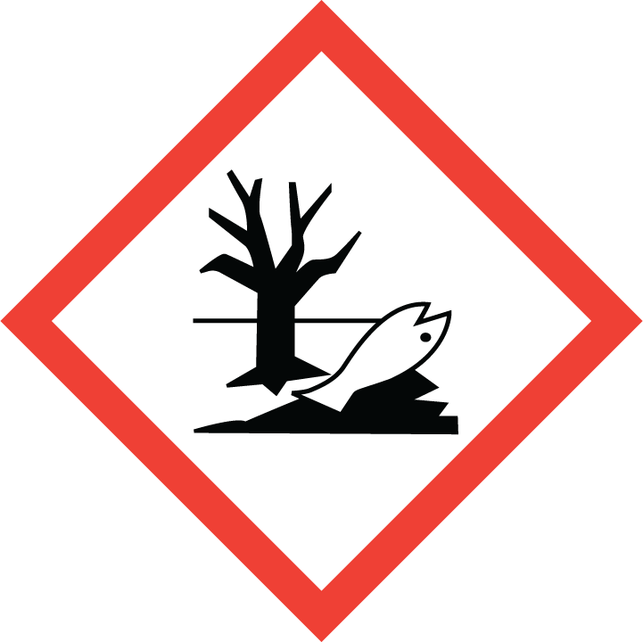 | 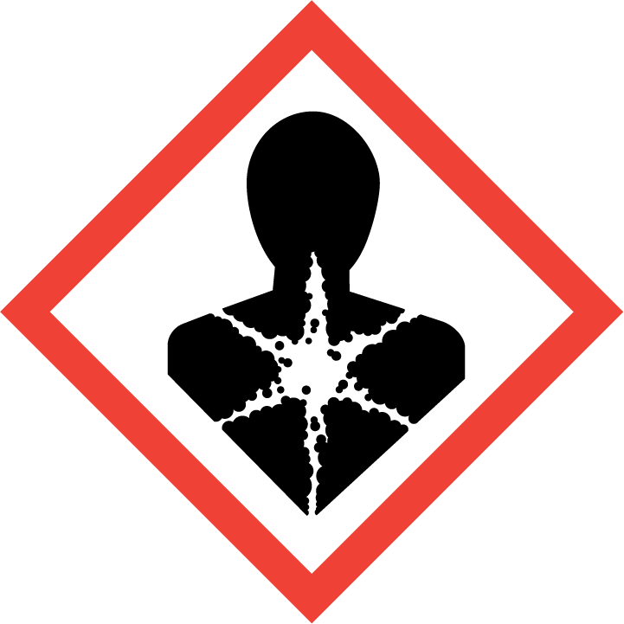
Flammable | Toxic | Harmful | Oxidising | Corrosive | Explosive | Harmful to the environment | Health Hazards i.e. respiratory sensitisation or carcinogenicity

SMOKING, EATING AND DRINKING ARE PROHIBITED IN THE WORK AREAS.
Information, Instruction and Training must be provided to all users. Young Persons, New or Expectant Mothers and other vulnerable groups must not use or be exposed to this product.

WORKPLACE EXPOSURE LIMITS (WEL’s)
No occupational exposure limits assigned for this product.

IMPORTANT!
Refer to Workplace Exposure Levels information provided in the Manufacturers Safety Data and revise control measures if exposure levels likely to be reached.

ROUTE OF EXPOSURE
Skin |  | Eyes |  | Inhalation
Ingestion |  | Cuts/abrasions |  | Systemic

PERSONS AT RISK
User of product |  | Co workers |  | Members of the public

ROUTE OF EXPOSURE |   FIRST AID MEASURES
Eyes | There may be irritation and redness. Bathe the eye with running water for 15 minutes.
Skin | There may be mild irritation at the site of contact. Wash immediately with plenty of soap and water.
Inhalation | There may be irritation of the throat with a feeling of tightness in the chest. Consult a doctor.
Ingestion | There may be irritation of the throat. Wash out mouth with water.
In all cases of doubt, or if symptoms persist seek medical attention. Never give anything by mouth to an unconscious person. If unconscious, place in recovery position and seek medical advice.

PERSONAL PROTECTIVE EQUIPMENT
 |  | 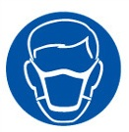 |  | 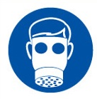 |  | 
YES | YES | YES/NO |  | YES/NO | YES | YES/NO
YES | YES |  |  |  | YES

HANDLING | STORAGE | TRANSPORT | DISPOSAL
Avoid the formation or spread of dust in the air. | Store in cool, well-ventilated area. | This product does not require a classification for transport. | No specific instructions given by manufacturer on disposal. Dispose of in accordance with local and national regulations.

REQUIRED CONTROL MEASURES
- Avoid contact with skin and eyes, and inhalation of vapours/ spray or mist arising from the application of this preparation – Use PPE.
- Only opened solvent containers should be kept at the bench.
- When not in use, opened solvent containers should be kept in the flammables cupboards, under the work benches.
- Surplus/ un-opened solvents must be kept in stores/ parts department.
- Ensure adequate welfare and washing facilities available and provide users with barrier and restorative creams. Take good hygiene measures.
- Ensure operatives are made aware of and understand the purpose of this assessment and MSDS, plus any health implications of using the product.
- Ensure COSHH assessments with accompanying MSDS are made available for all employees and users and for inspection and emergency purpose.
- Good industrial hygiene practices should be observed. Wash hands before work breaks and after finishing work.

FIRE PRECAUTIONS
This material is not flammable. Use extinguishing media appropriate for surrounding fire.

ACCIDENTAL RELEASE/SPILLAGE PROCEDURES
Wash the spillage site with large amounts of water.

MONITORING REQUIREMENTS AND HEALTH SURVEILLANCE
Health surveillance is not in place for workers exposed to this product.

